**CODE**

**Link to Long’ github *:*** [***winterevil (winterevil) / Repositories · GitHub***](https://github.com/winterevil?tab=repositories)

***Product 1 : “Homework”***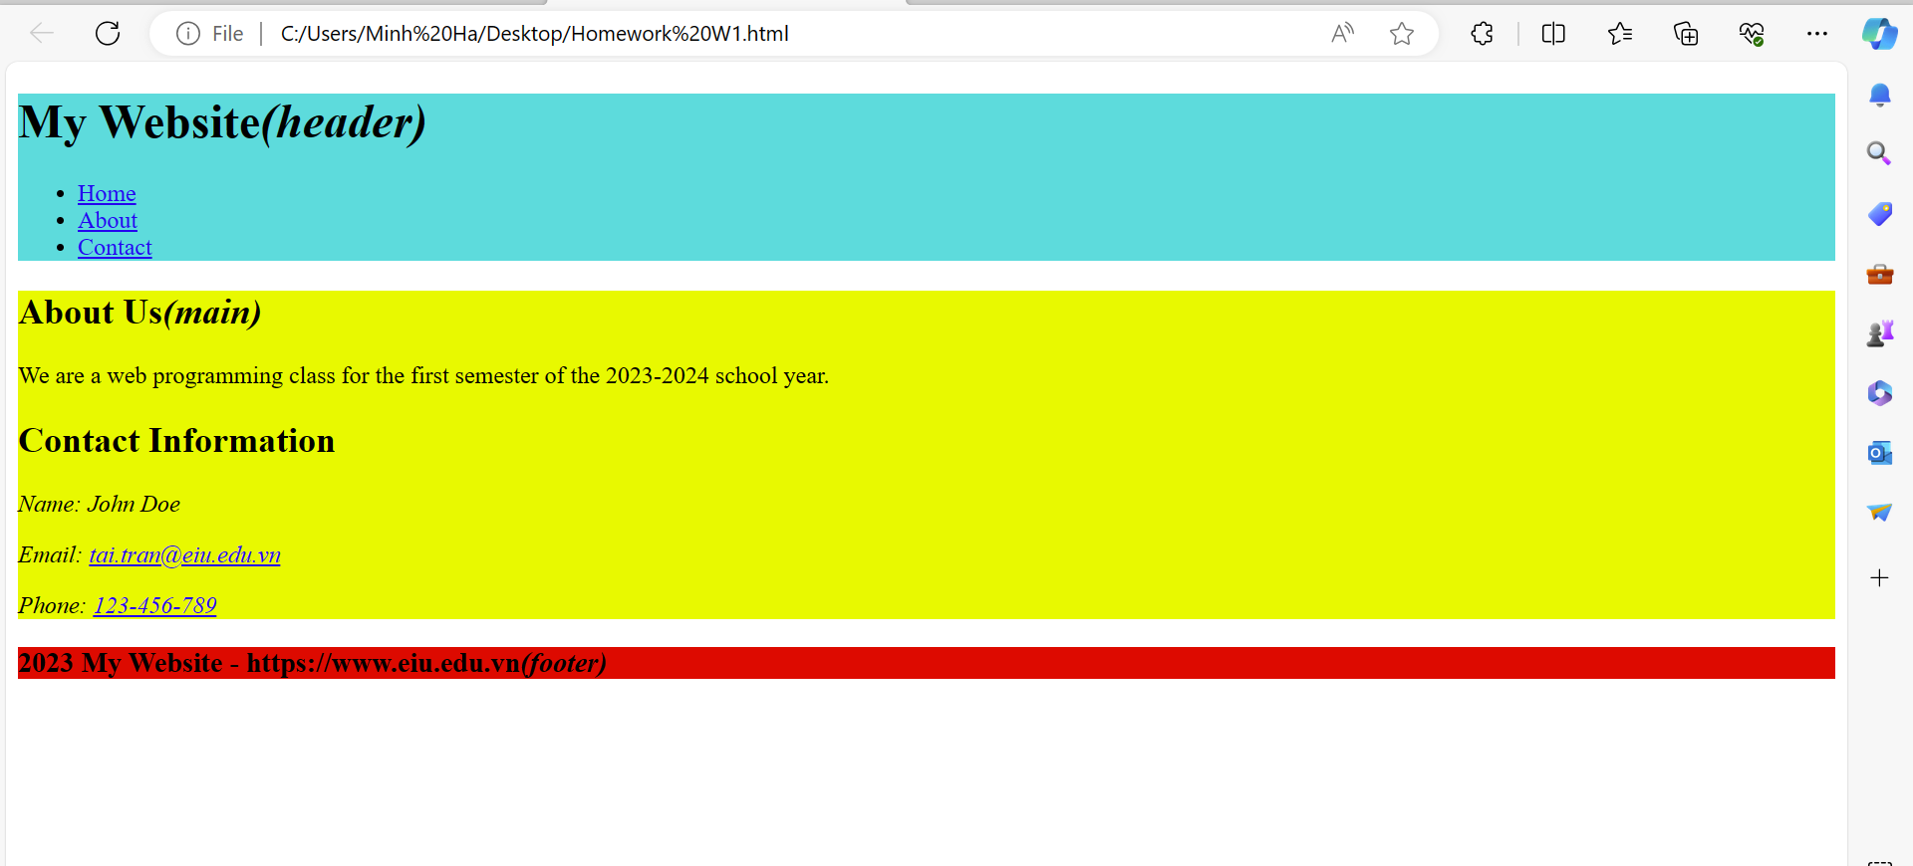

**Lab1_1.html**

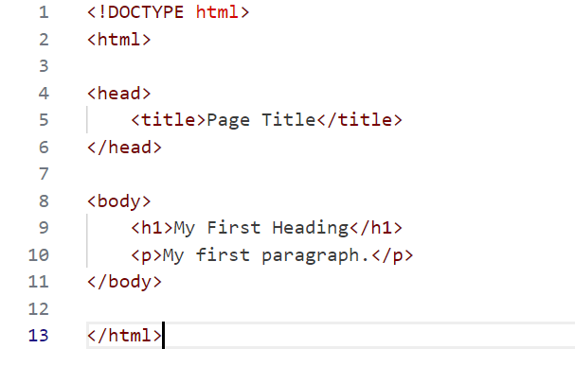

**Lab1_2p1.html**

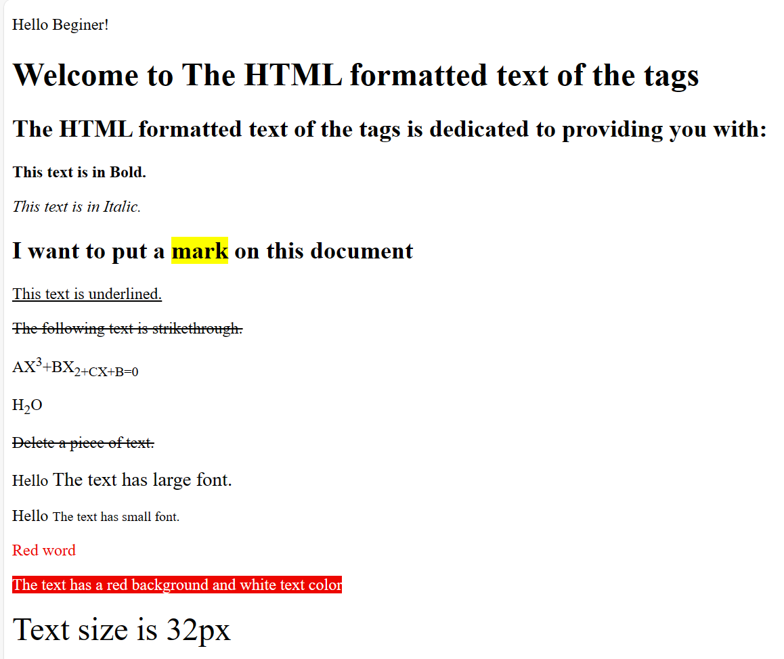

**Chú ý :**

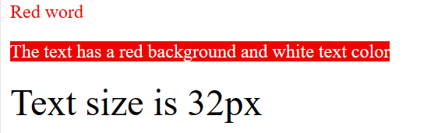

**CODE :**



**Lab1_2p2.html**

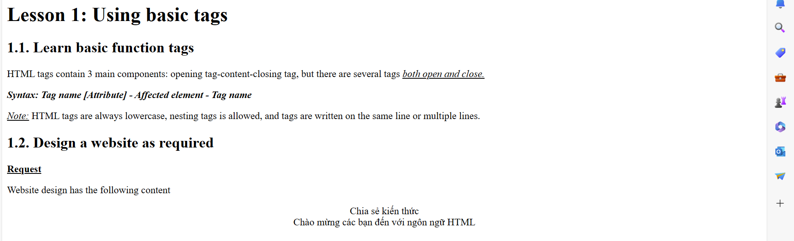

Chú ý viết canh lề vào giữa



**Lab1_2p3.html**

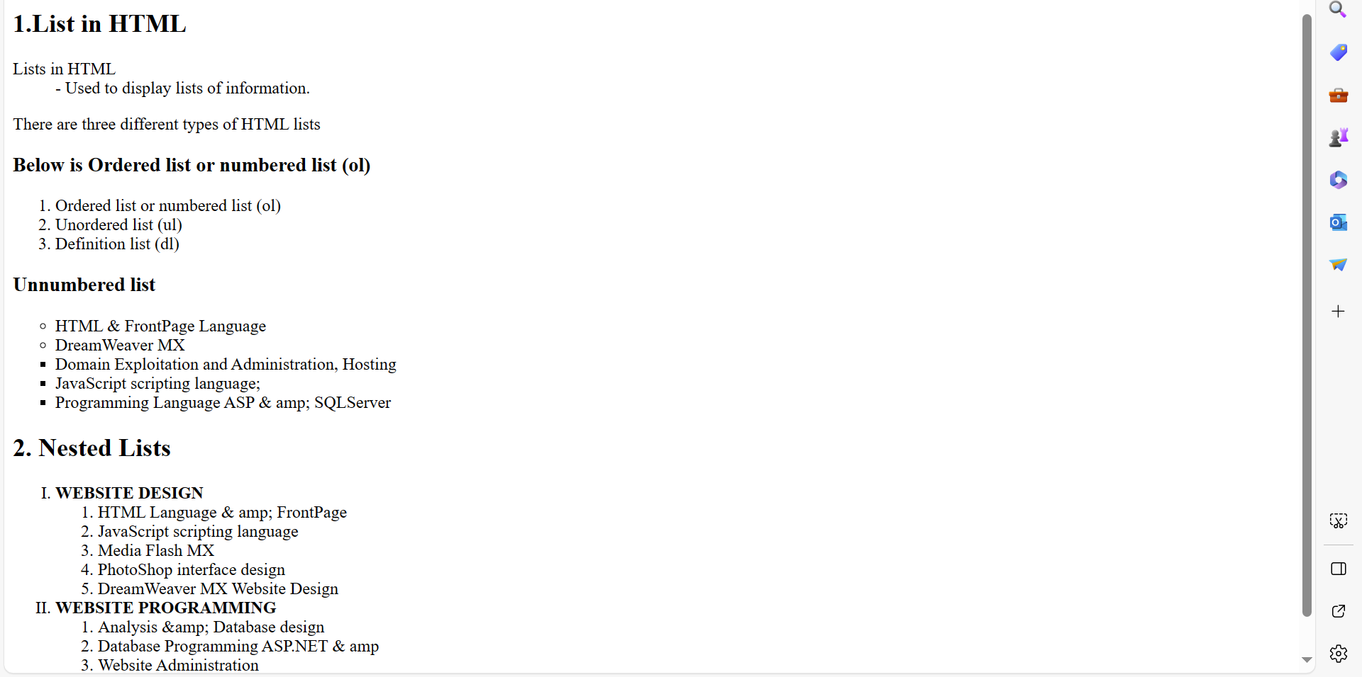

Theory:

* Tag <**dl**> : xác định danh sách ( có đề mục và phần mô tả đề mục).
* Sử dụng kết hợp với <**dt**> ( định nghĩa các mục trong danh sách - tiêu đề của mục )
* <**dd**> : mô tả các mục trong danh sách.
* Ví dụ : <https://www.w3schools.com/tags/tryit.asp?filename=tryhtml_ol_type_css>

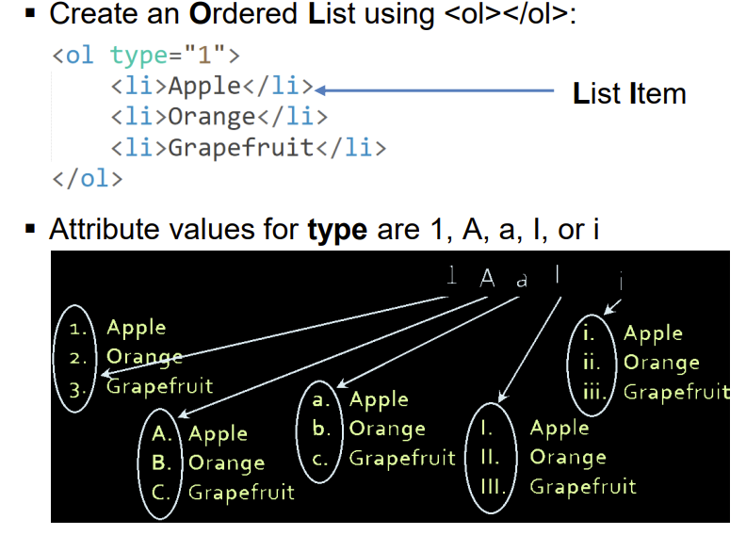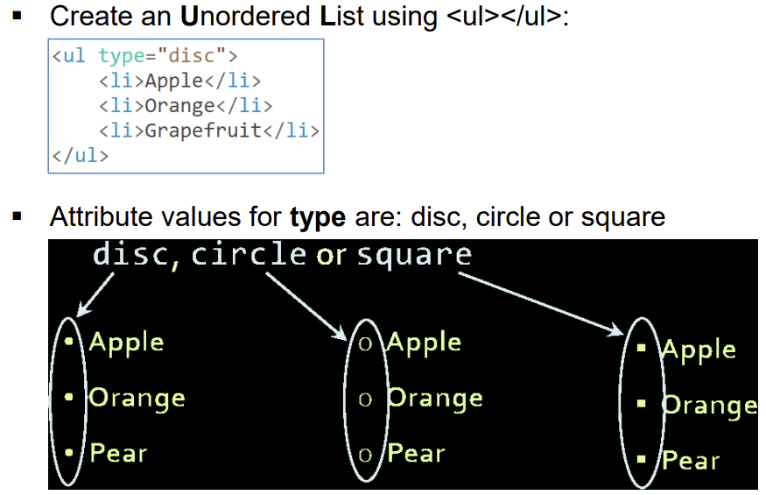

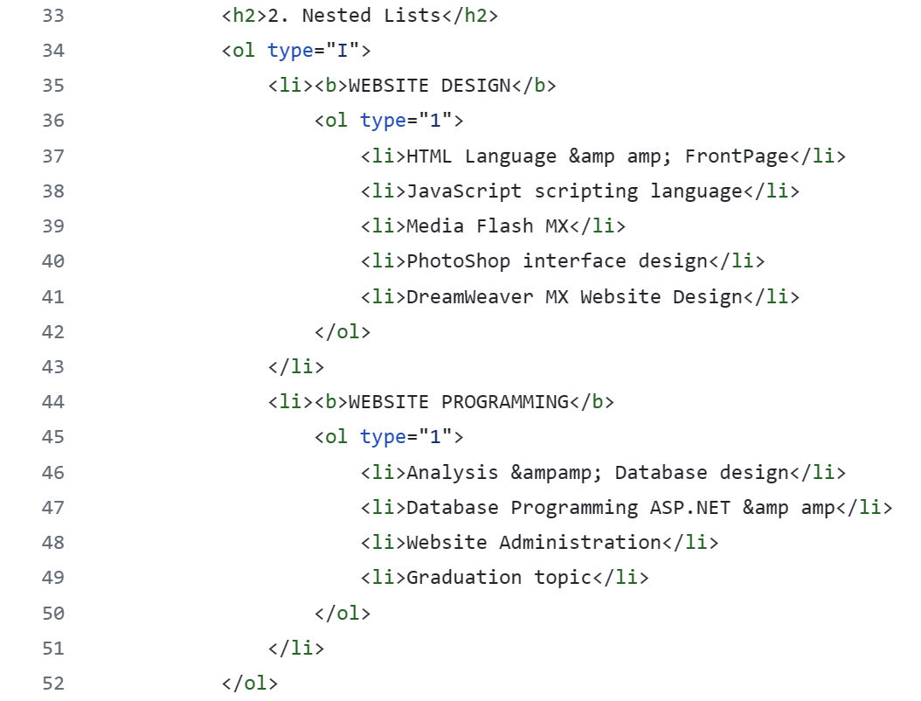

Cẩn thận khúc cuối 2. Nested Lists.

**Lab1_2p4.html**

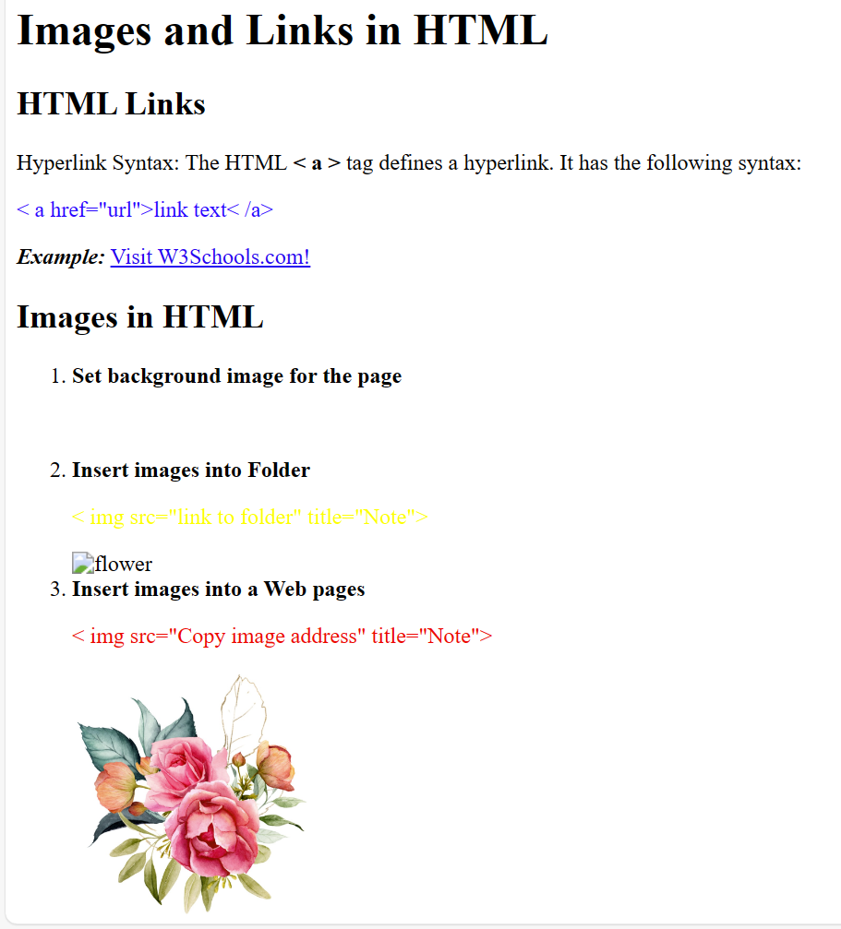

**Special** : gắn link , đổi màu chữ

<body background=” img/Background.jpg”

đổi màu chữ: <p><span style="color:blue;">< a href="url">link text< /a></span></p>

**Gắn link** : <p><b><i>Example:</i></b> <a href="https://www.w3schools.com/">Visit W3Schools.com!</a></p>

Đoạn images in HTML

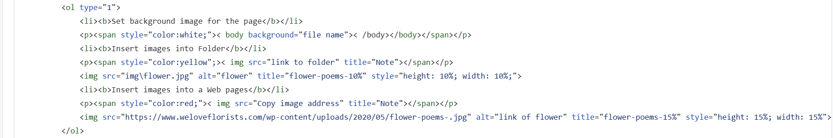

**Lab1_2p5.html**

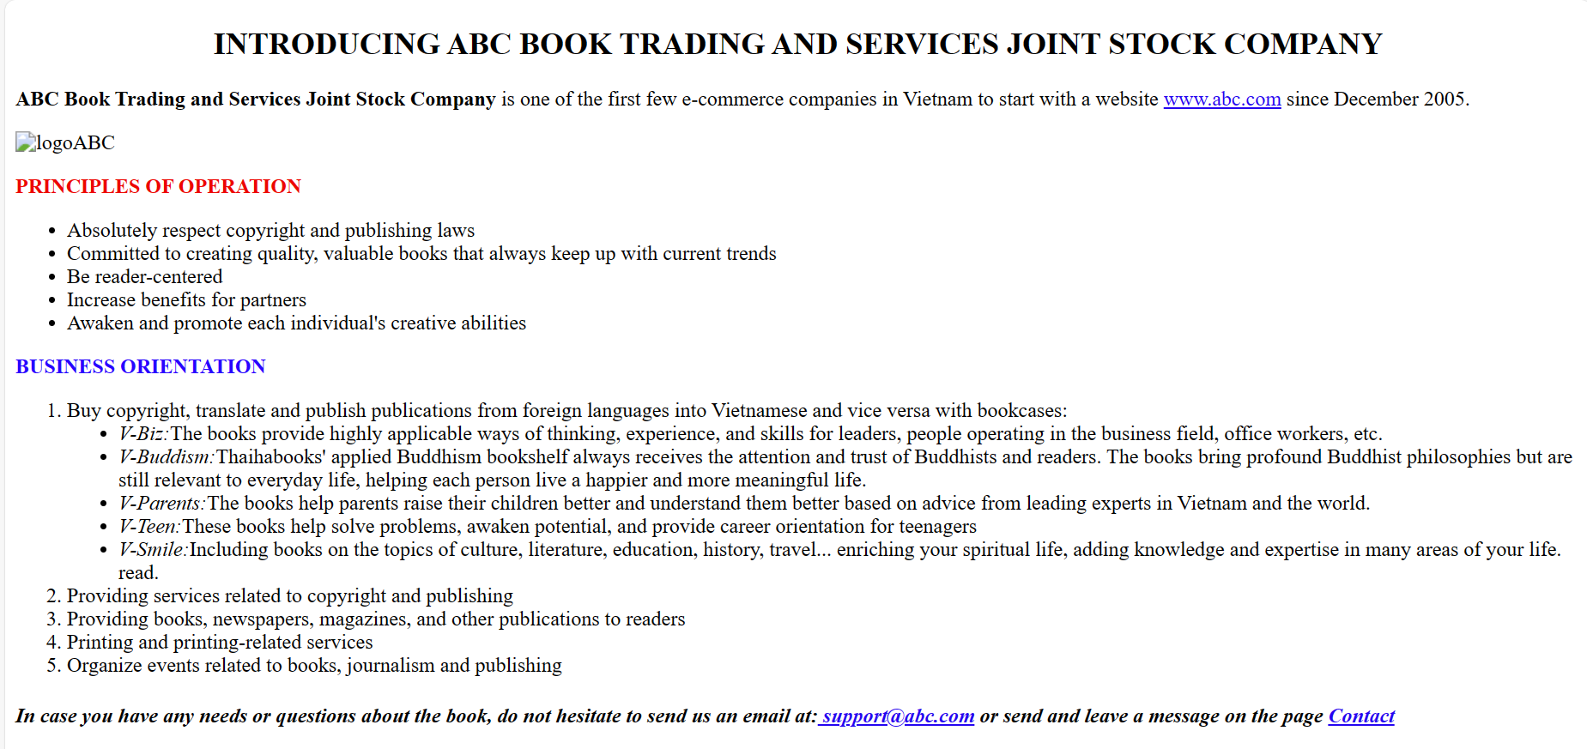

Link to CODE : [Lab01_LeThanhLong/Lab1_2p5.html at main winterevil/Lab01_LeThanhLong (github.com)](https://github.com/winterevil/Lab01_LeThanhLong/blob/main/Lab1_2p5.html)

**Product : Assignment**

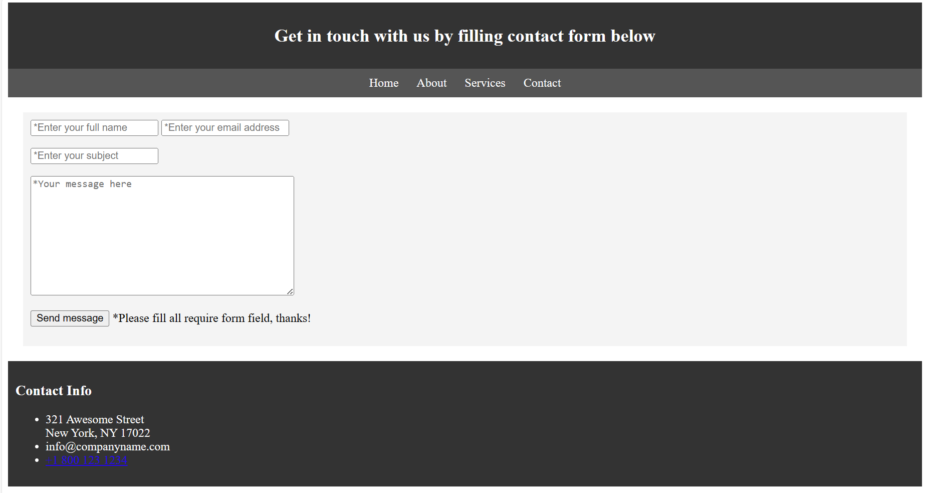

Special : Dữ liệu from users. Headers. Ul or Dl

**Firstly** : Tạo dòng headers and **Menu** ngang :

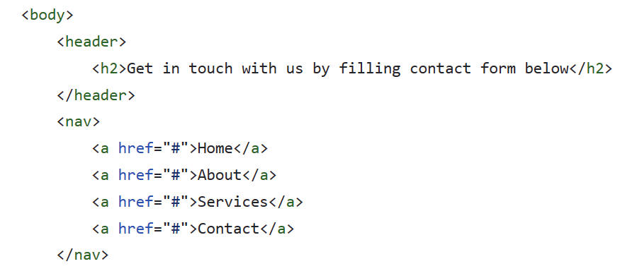

**Secondly : Users enter**

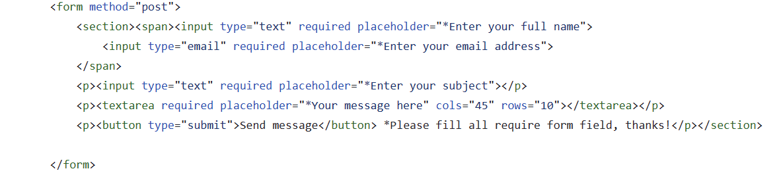

**Finally : Style : Link coi code :** [**Assignment/Ex1w3.html at main · winterevil/Assignment (github.com)**](https://github.com/winterevil/Assignment/blob/main/Ex1w3.html)

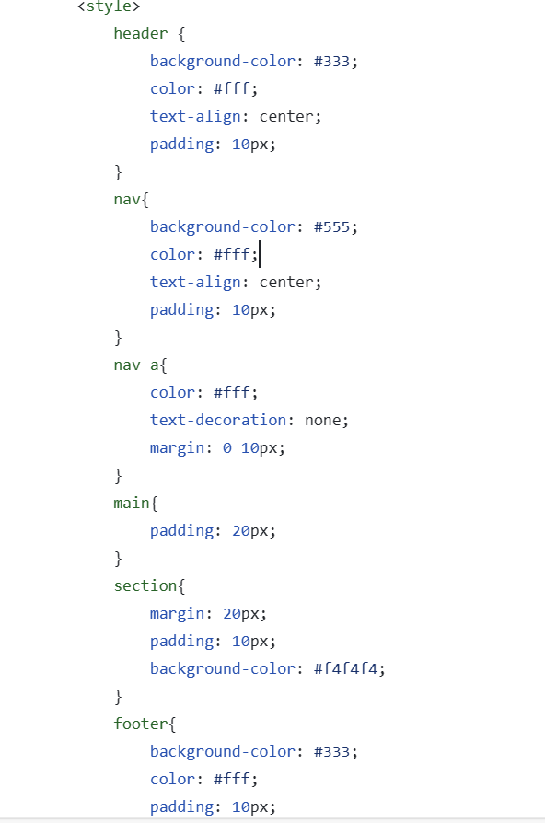

**Lab2_3.html**

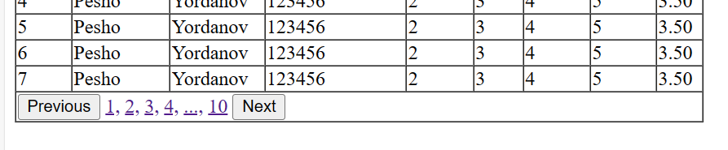

Code

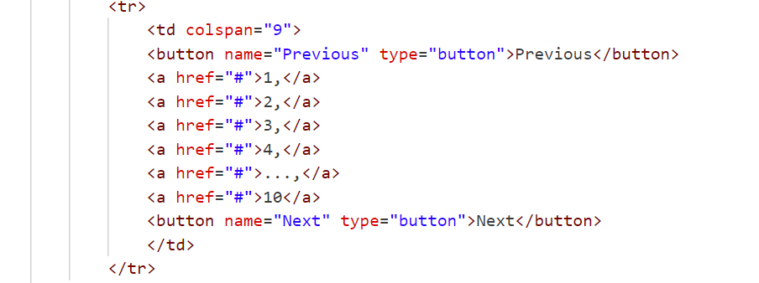

**Lab2_4.html**

Link : [Lab02_LeThanhLong/Lab2_4.html at main · winterevil/Lab02_LeThanhLong (github.com)](https://github.com/winterevil/Lab02_LeThanhLong/blob/main/Lab2_4.html)

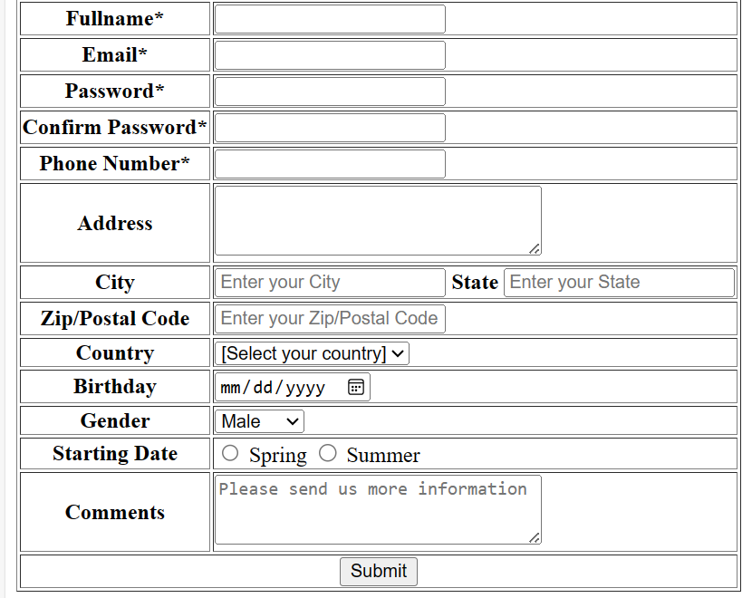

**Lab2_5.html**

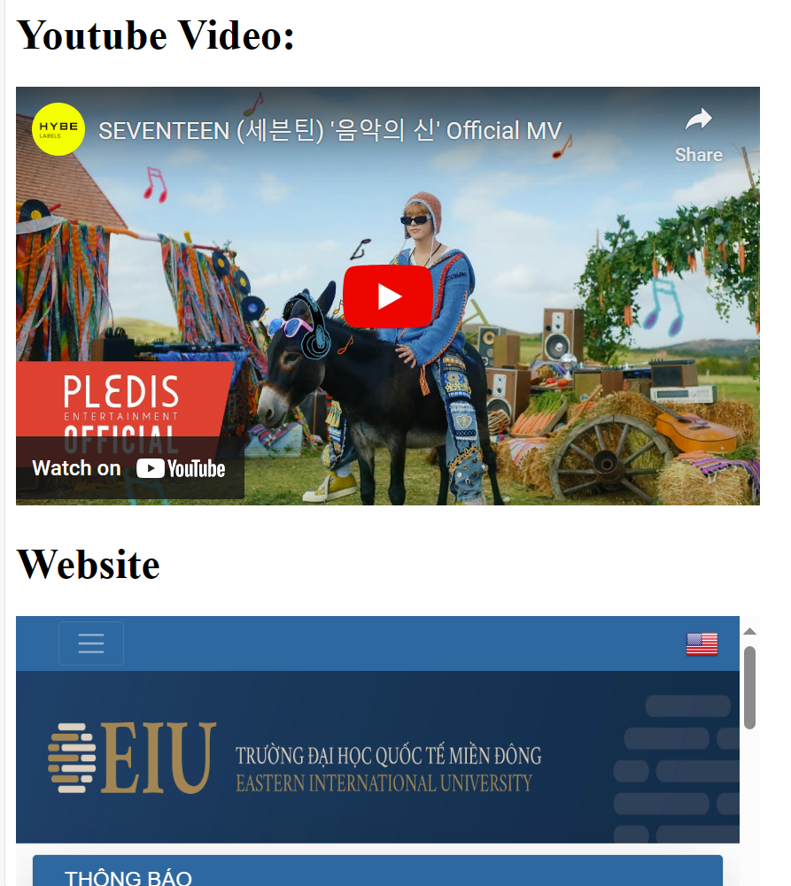

Link : [Lab02_LeThanhLong/Lab2_5.html at main · winterevil/Lab02_LeThanhLong (github.com)](https://github.com/winterevil/Lab02_LeThanhLong/blob/main/Lab2_5.html)

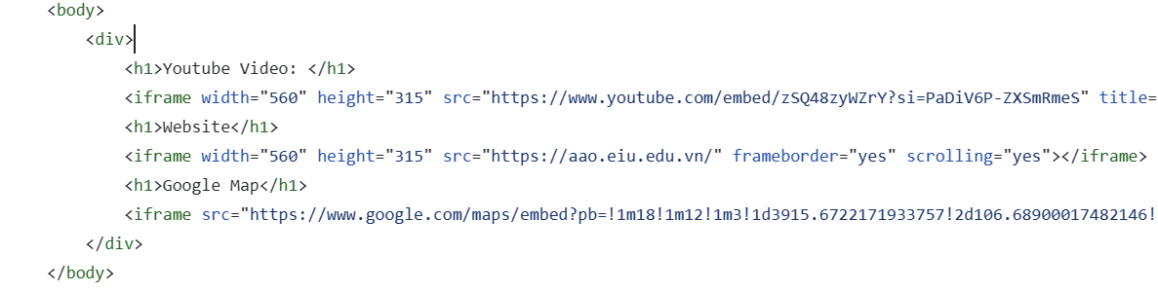

**DETAILPRODUCT.html**

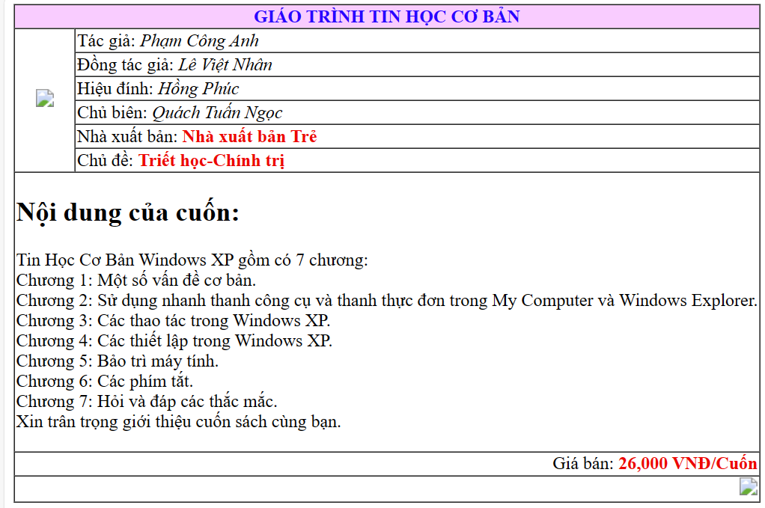

Link : [Lab02_LeThanhLong/detailproduct.html at main · winterevil/Lab02_LeThanhLong (github.com)](https://github.com/winterevil/Lab02_LeThanhLong/blob/main/detailproduct.html)

Link : [Lab02_LeThanhLong/left.html at main · winterevil/Lab02_LeThanhLong (github.com)](https://github.com/winterevil/Lab02_LeThanhLong/blob/main/left.html) : gắn link, làm màu nền

**Login**

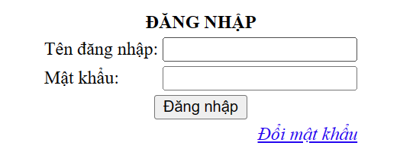

[Lab02_LeThanhLong/login.html at main · winterevil/Lab02_LeThanhLong (github.com)](https://github.com/winterevil/Lab02_LeThanhLong/blob/main/login.html)

**Register**

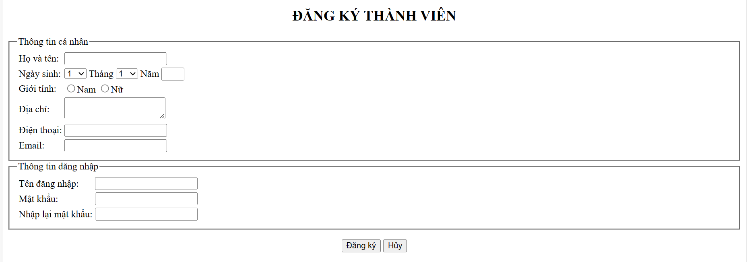

Link : [Lab02_LeThanhLong/register.html at main · winterevil/Lab02_LeThanhLong (github.com)](https://github.com/winterevil/Lab02_LeThanhLong/blob/main/register.html)

—---------------------------------------------------------------------------------------------------------------

**Lab3.html**

[Lab03_LeThanhLong/Header.html at main · winterevil/Lab03_LeThanhLong (github.com)](https://github.com/winterevil/Lab03_LeThanhLong/blob/main/Header.html)



**Lab3.html ( homepage )**

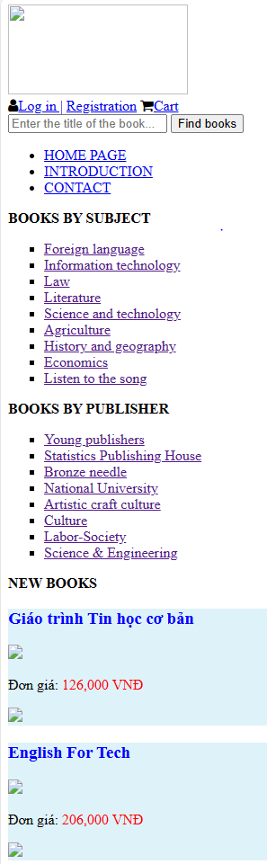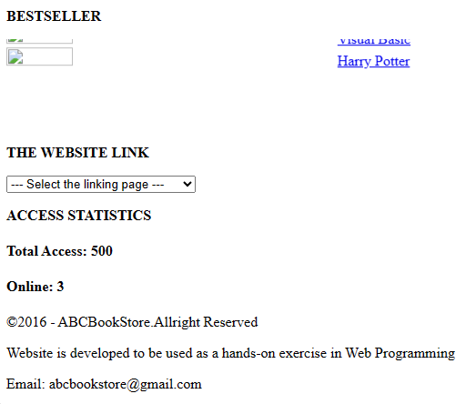

[Lab03_LeThanhLong/Homepage.html at main · winterevil/Lab03_LeThanhLong (github.com)](https://github.com/winterevil/Lab03_LeThanhLong/blob/main/Homepage.html)

**Lab3.html ( Registration)**

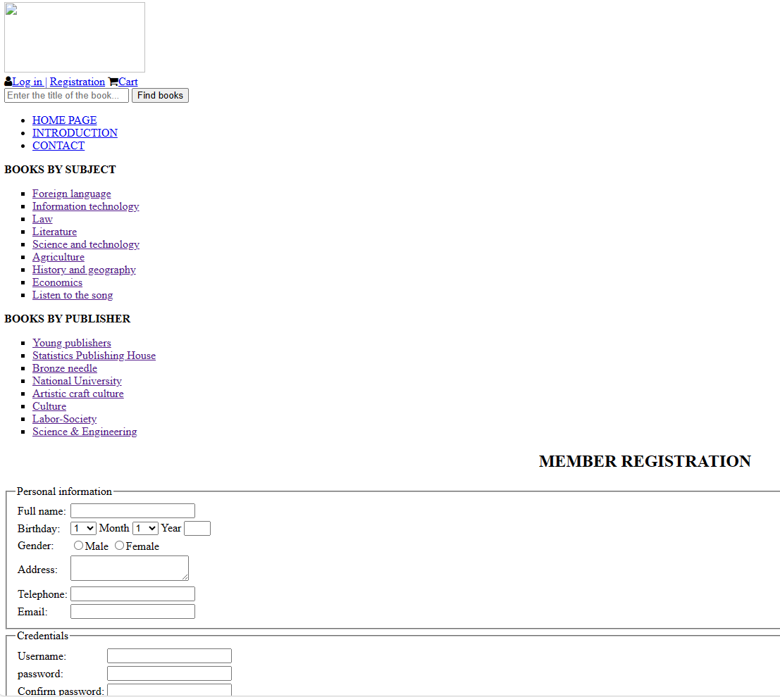

[Lab03_LeThanhLong/Registration.html at main · winterevil/Lab03_LeThanhLong (github.com)](https://github.com/winterevil/Lab03_LeThanhLong/blob/main/Registration.html)

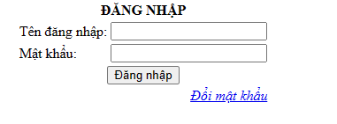

[Lab03_LeThanhLong/login.html at main · winterevil/Lab03_LeThanhLong (github.com)](https://github.com/winterevil/Lab03_LeThanhLong/blob/main/login.html)

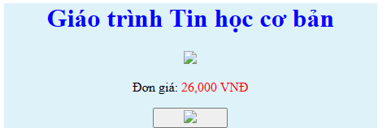

[Lab03_LeThanhLong/product.html at main · winterevil/Lab03_LeThanhLong (github.com)](https://github.com/winterevil/Lab03_LeThanhLong/blob/main/product.html)

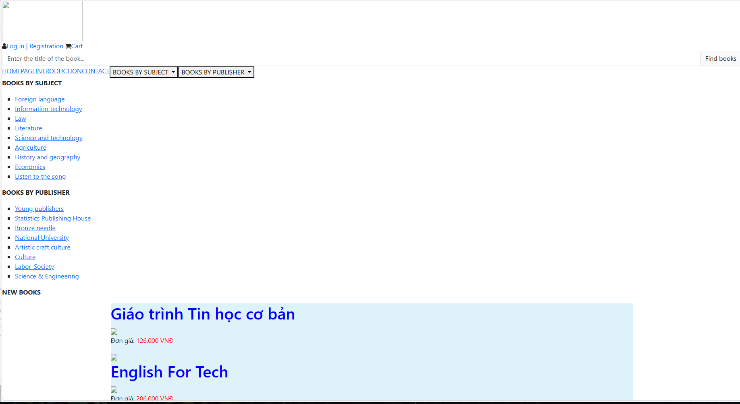

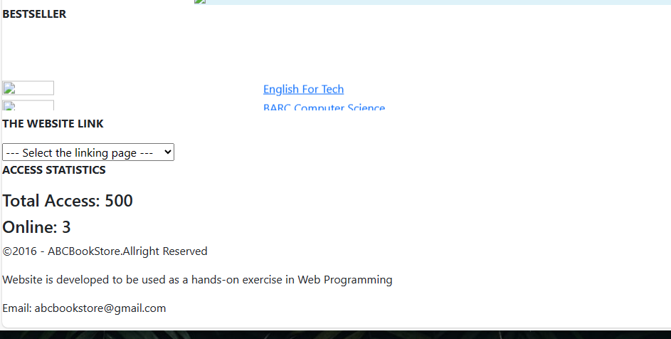

[Lab05_LeThanhLong/Homepage.html at main · winterevil/Lab05_LeThanhLong (github.com)](https://github.com/winterevil/Lab05_LeThanhLong/blob/main/Homepage.html)

[Lab06_LeThanhLong/Lab06_p2.html at main · winterevil/Lab06_LeThanhLong (github.com)](https://github.com/winterevil/Lab06_LeThanhLong/blob/main/Lab06_p2.html) Tính toán

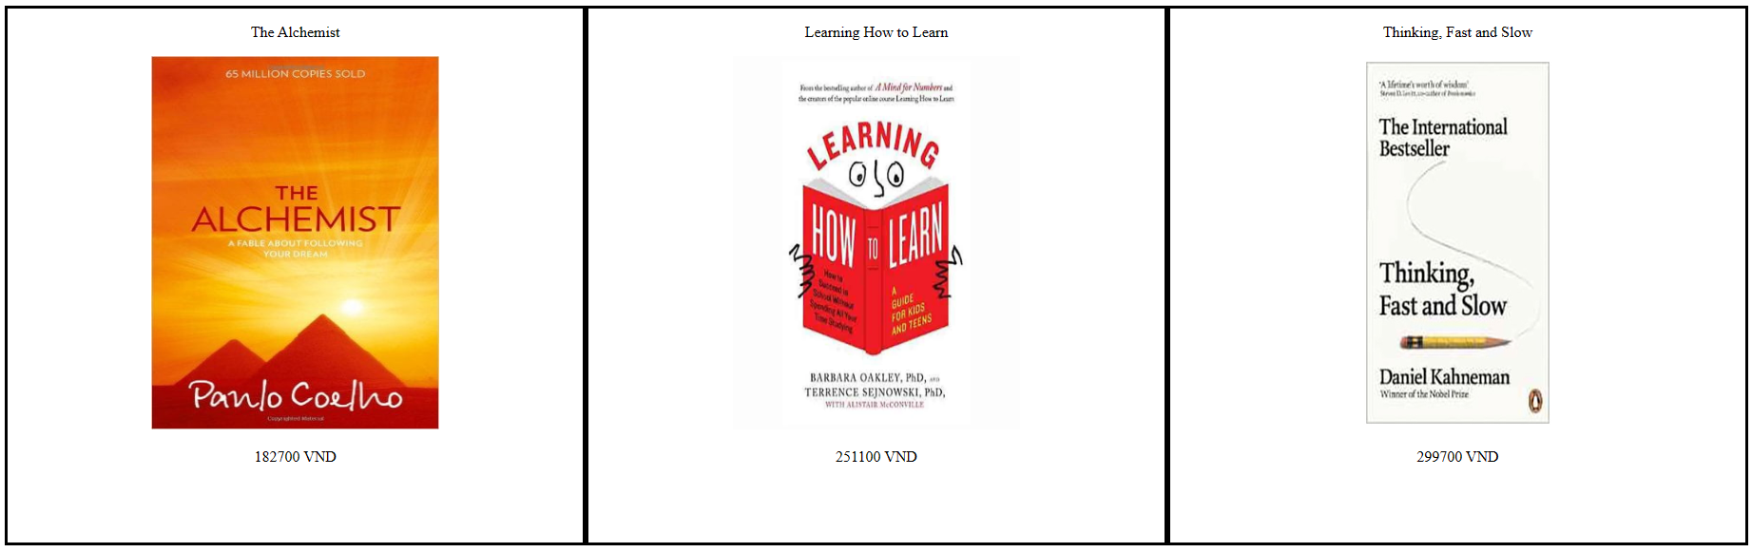

[Lab06_LeThanhLong/Lab06_p3.html at main · winterevil/Lab06_LeThanhLong (github.com)](https://github.com/winterevil/Lab06_LeThanhLong/blob/main/Lab06_p3.html)

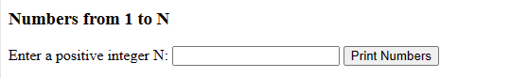

[Lab06_LeThanhLong/Lab06_p5.html at main · winterevil/Lab06_LeThanhLong (github.com)](https://github.com/winterevil/Lab06_LeThanhLong/blob/main/Lab06_p5.html)

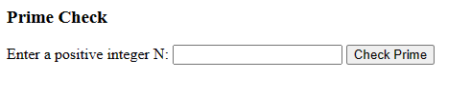

[Lab06_LeThanhLong/Lab06_p6.html at main · winterevil/Lab06_LeThanhLong (github.com)](https://github.com/winterevil/Lab06_LeThanhLong/blob/main/Lab06_p6.html)

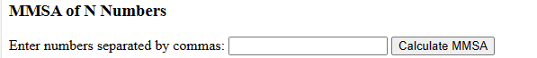

[Lab06_LeThanhLong/Lab06_p7.html at main · winterevil/Lab06_LeThanhLong (github.com)](https://github.com/winterevil/Lab06_LeThanhLong/blob/main/Lab06_p7.html)

**Lab7.html ( Registration)**

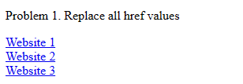

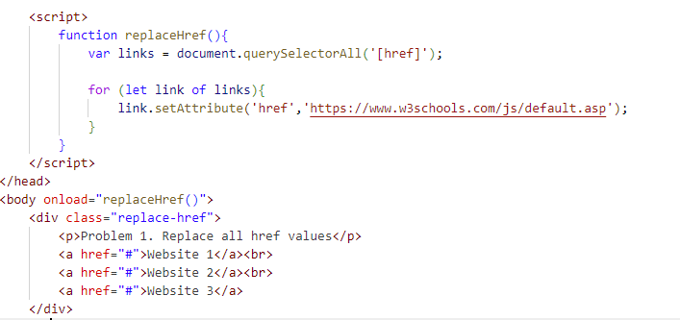

**Lab7.2 html ( Registration)**

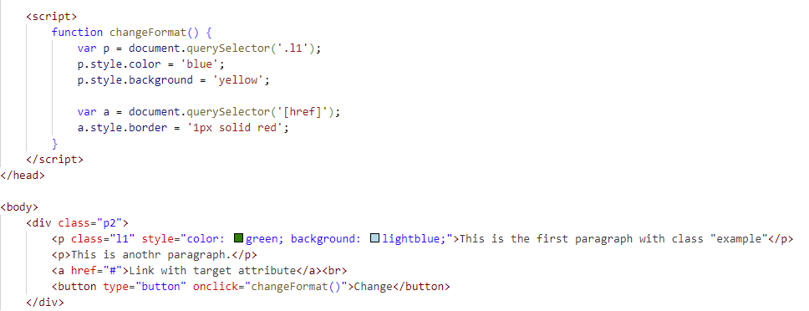

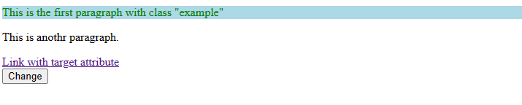

**Lab7.3 html ( Registration)** [**https://github.com/winterevil/Lab07_LeThanhLong/blob/main/Lab07_p3.html**](https://github.com/winterevil/Lab07_LeThanhLong/blob/main/Lab07_p3.html)

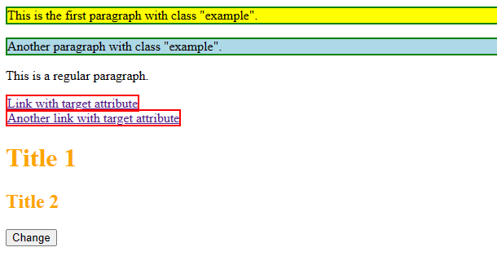

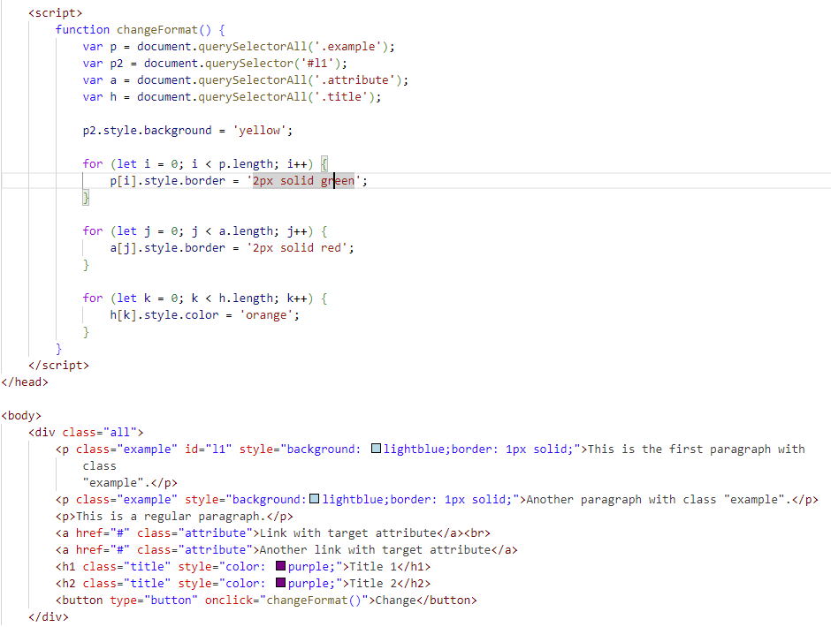

**Lab7.4 html ( Registration)**

<https://github.com/winterevil/Lab07_LeThanhLong/blob/main/Lab07_p4.html>

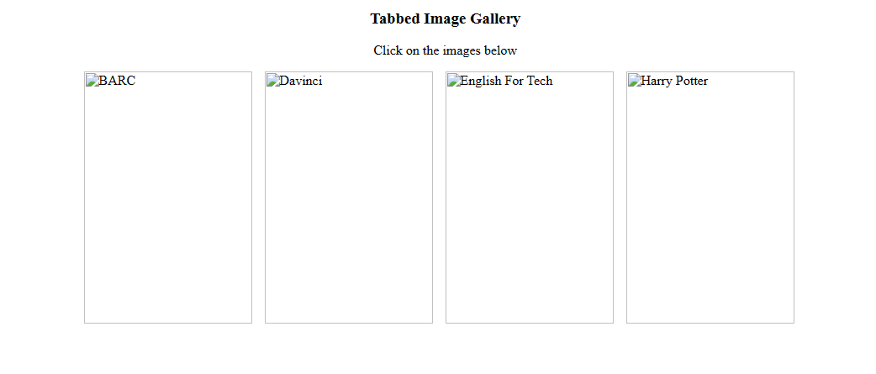

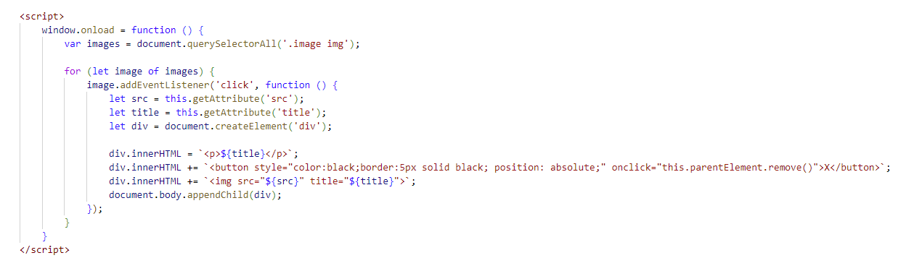

**Lab7.5 html ( Registration)**

<https://github.com/winterevil/Lab07_LeThanhLong/blob/main/Lab07_p5.html>

